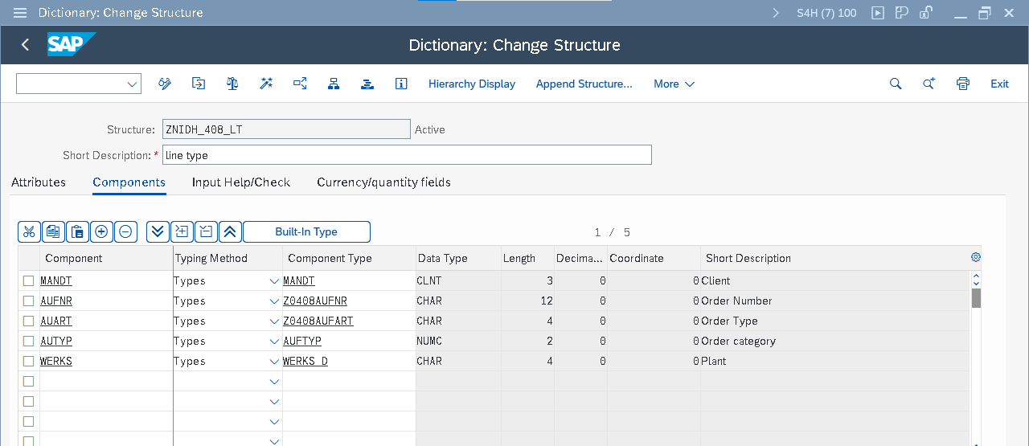

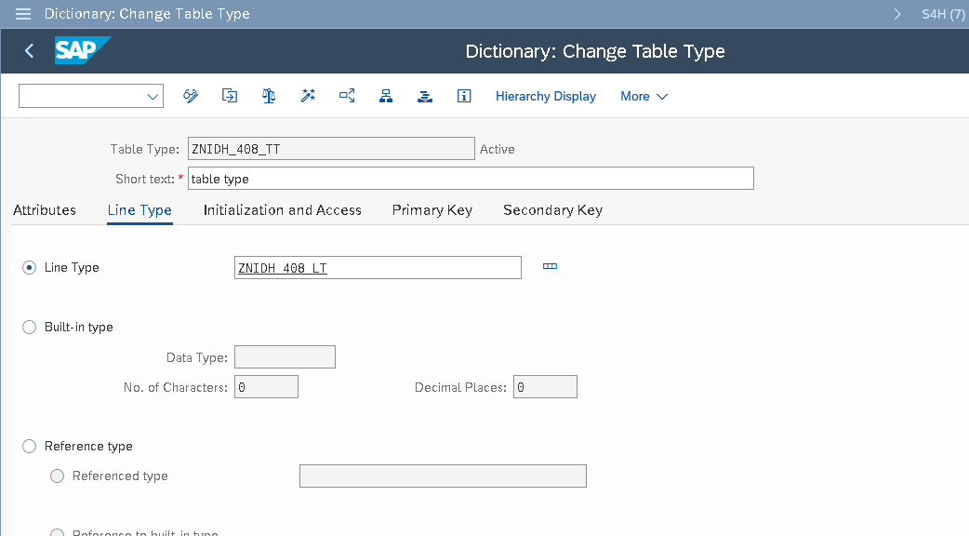

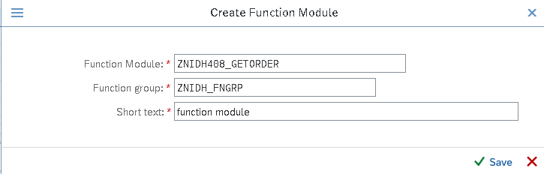

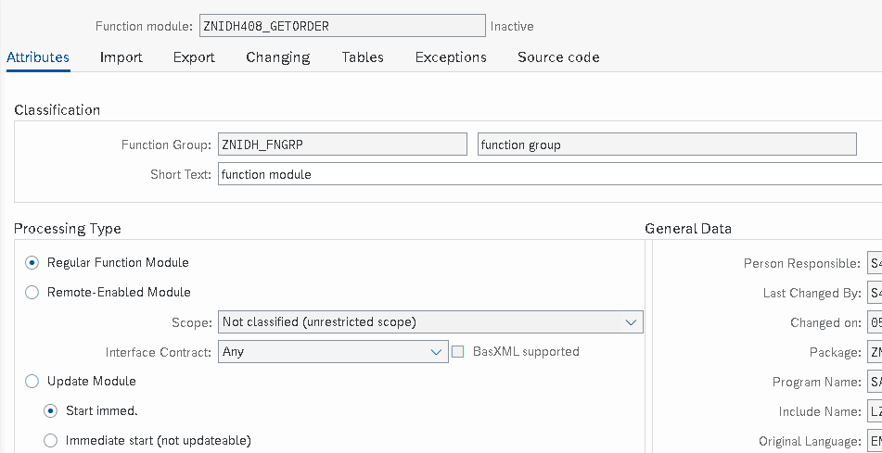

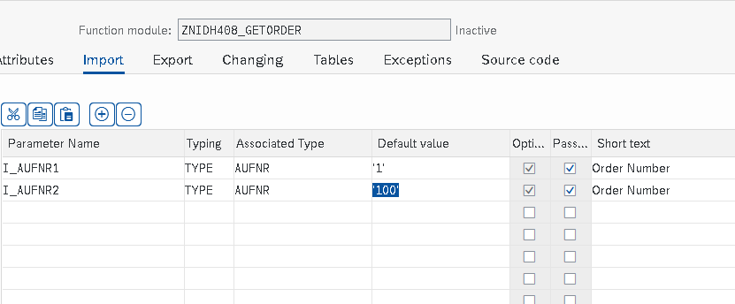

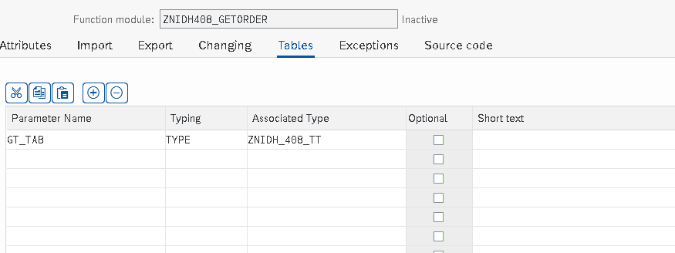

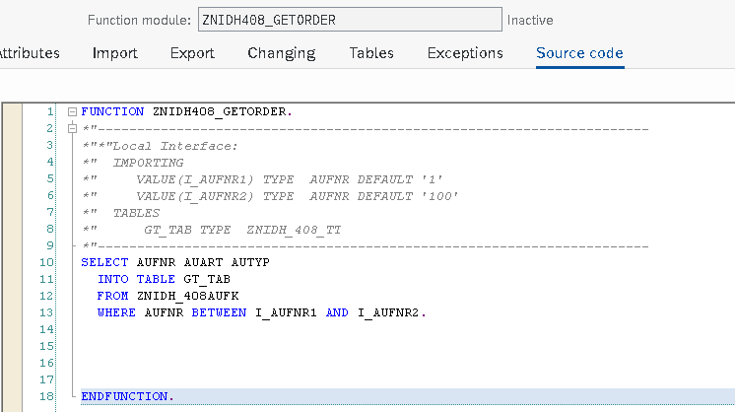

*&---------------------------------------------------------------------*  
*& Report ZNIDH408_FM_PRGM  
*&---------------------------------------------------------------------*  
*&  
*&---------------------------------------------------------------------*  
                                                         .  
REPORT ZNIDH408_FM_PRGM.  
  
data: lt_tab type ZNIDH_408_TT,  
      wa_tab type ZNIDH_408_LT.  
  
select-OPTIONS s_aufnr for wa_tab-aufnr.  
  
START-OF-SELECTION.  
  
CALL FUNCTION 'ZNIDH408_GETORDER'  
EXPORTING  
   I_AUFNR1       = s_aufnr-low "'1'  
   I_AUFNR2       = s_aufnr-high"'100'  
  TABLES  
    gt_tab         = lt_tab.  
  
perform disp_aufk_data.  
          .  
*&---------------------------------------------------------------------*  
*& Form disp_aufk_data  
*&---------------------------------------------------------------------*  
FORM disp_aufk_data .  
  
 loop at lt_tab into wa_tab.  
   write:/ wa_tab-aufnr,  
           wa_tab-auart,  
           wa_tab-autyp.  
  
  
   ENDLOOP.  
  
  
  
ENDFORM.

